RYEDALE LDF

THE RYEDALE PLAN

Comments of Councillor Paul Andrews

Comments on Housing

The nature of the two towns

Malton is a country market town and with its neighbour Norton forms a single community. The towns are situated in the centre of the district of Ryedale, about mid-way between York and Scarborough. York and Scarborough are both sub-regional centres, while Malton & Norton are one of four towns within a large rural district. As such, Malton and Norton constitute a small district centre. Many local families have lived in the district for over fifty years, and expect the towns to have the amenities of a small district centre, such as local shops, with easy, uncongested access, employment opportunities, good schools and streets where old people can feel safe at night. They do not expect the allurements of a regional or sub-regional centre, and do not want the congestion, crime and lack of social harmony and cohesion which come with an urban way of life. They expect incoming residents to adapt to the country way of life and to be part of the community.

The Community Aspect

Malton and Norton are a single community divided by the River Derwent. The population of both towns is 12,370. In 2008 there were 5,527 houses (3,178 in Norton and 2,349 in Malton).

The issue is how fast this community can grow without losing its identity. Clearly it is unwise to be unduly restrictive of growth but the rate of growth should be that which allows incoming residents to be assimilated into the community in such a way and at such a speed as promotes harmony and maintains social cohesion. If the rate of growth is too high, this may lead to disruption of the community and a lack of balance, with increased consequences of crime and anti-social behaviour.

Clearly the chief issue is the matter of balance. There would appear to be no criteria to determine the most healthy rate of growth. When consulted in 2009, the Town Councils took the view that Malton & Norton could accept a maximum of 1,000 new houses over a fifteen year period (ie. one third of all new housing development across Ryedale District). The Ryedale Plan, however, requires that Malton and Norton should have approximately 50% of all new development – i.e about1500 new houses over a fifteen year period.

Table 4.9 of an Employment Review Update by Entec dated June 2010 (reproduced below as Figure 1 ) , shows the increased employment which will be generated by increased housing. Bearing in mind the present population of around 12,000, this illustrates how a large increase in population can become disproportionate.

It is worth noting, however, that the recommended Scenario 4A of the Jacobs Strategic Transport Assessment (see Section on Highways) fixes the maximum number of new houses that should be provided in Norton and Malton at 2,165. It is feared that this is the real number of new houses which the District Council intends to authorise.

An increase of this size would be roughly equivalent to the addition of about as many new houses as already existed in the whole of Malton Ward in 2008.

An increase of 1500 houses represents an increase of 27% of the houses of both towns and 64% of the houses in Malton alone.

It is suggested that any increase of population in excess of that generated by 1,000 new houses will be disproportionate, and that it will not be possible to assimilate such a large number of new residents into the life of the towns in this time scale (e.g. the lifetime of the new LDF.)

Figure 1

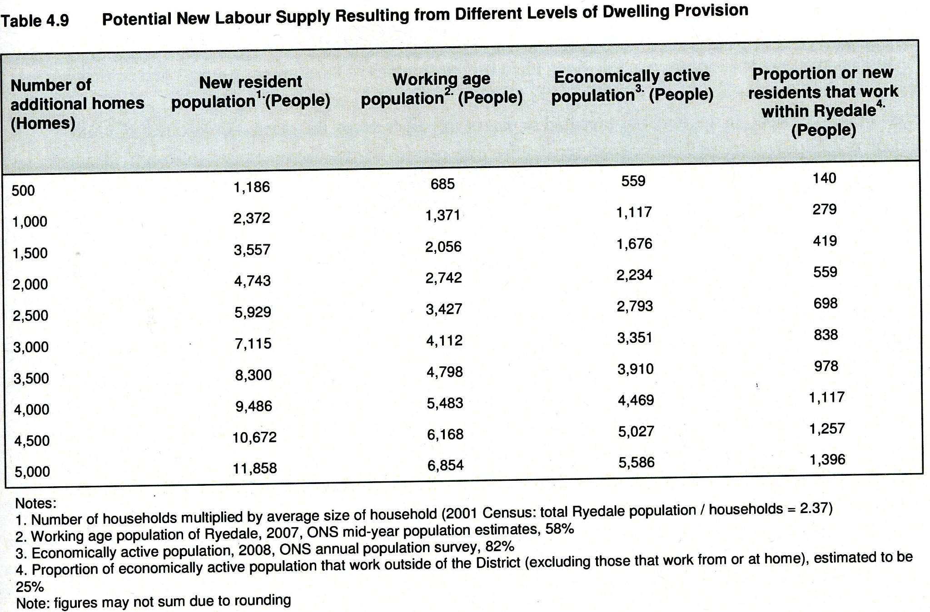
Source: Entec RDC Employment Land Review Update June 2010

The Highways Infrastructure

As mentioned in the section on Highways, many of the road junctions within Malton & Norton, particularly the key Butcher corner junction, are already over capacity. In the Highways Section the view is taken that the Jacobs STA report is based on flawed assumptions and its final recommendations are therefore also flawed. It is therefore likely that even as many as 1,000 new dwellings for the two towns will put undue strain on an already inadequate road infrastructure.

There is an additional issue in relation to access to the A64. For the reasons previously set out, there is a clear need for a new four way grade separated road junction between the A64 and Broughton Road. This need has become even more urgent than the improvements to the Brambling Fields Junction (currently under construction), particularly for the residents in new homes in Malton.

Developer Contributions

The A 64 Malton bypass has only one four-way grade separated junction, at Old Malton. The other two junctions (York Road and Brambling Fields) are two-way and three-way junctions, respectively. This is far from satisfactory and for many years efforts have been made to find public funding to make York Road and Brambling Fields both four-way. These efforts have failed. So, in the last few years Ryedale has resorted to planning gain under Section 106 agreements to raise the balance of the required funds for making Brambling Fields four-way.

The larger the development, the more the planning gain. The corollary is that the larger the development, the greater the generation of vehicle movement, and the greater the negative impact on town centre junctions. So, in resolving one problem, RDC is causing another problem to worsen.

When the traffic generated by the Bacon Factory at Noton was much greater than it is now, there was a greater need to make Brambling Fields four-way. However, now that the Bacon Factory’s output has decreased by two thirds, the need for this particular road improvement has diminished.

At the same time, projected costs have increased:
Originally, it was thought that only a fourth slip road was required.
Then it was decided that there should be two roundabouts on either side of the bridge. This was then found to require a realignment of the other slip roads.

All this has virtually doubled the anticipated cost, and with the cost increase has come a greater urgency to obtain twice as much planning gain. This seems to have led to the granting of more planning consents for developments of large housing estates outside the current saved development limits. This in turn will result in the generation of more vehicle movements, which puts ever more pressure on the road junctions, already over-capacity, in the town centres.

Other infrastructure

Numbers of new houses also increase pressure on other local services, such as drainage and sewerage, schools and leisure services.
RDC proposes to generate capital to pay for this by requiring more developer contributions. However, since money is unavailable until a development starts, and as developments may be delayed as a result of the Recession, it becomes almost impossible to plan ahead with any degree of certainty.

Demand

The 1994-2009 Ryedale Local Plan, which remains in force until the new Plan is adopted, assumed a building rate of 180 houses a year, while the Regional Spatial Strategy required RDC to produce 200 dwellings a year for the whole of Ryedale.

Actual building rates over the last eight years are shown on Figure 2

Figure 2

‘We have detailed information on housing completions from 2002-2010, which is shown below. However prior to that we only have average completions for the period 1991-2002. The average number of completions for this period was 200 dwellings per annum. For 2002 to 2010 the average for gross dwelling completions was 151 per annum. This is based on the following gross housing completions over that period:
02-03 - 119
03-04 - 194
04-05 - 113
05-06 - 121
06-07 - 202
07-08 - 233
08-09 - 106
09-10 – 122’

Source: Ryedale District Council Planning Department.

This reveals an average building rate of 150 houses a year, although if two of the years were excluded, the actual rate is about 116 houses a year.
RDC have projected a need for 3,500 new houses over a fifteen year period, although if the figure of 150 dwellings is multiplied, the number of new dwellings required over a fifteen year period is actually 2,250.

It should be noted that the average building rate of 150 houses a year does not seem to be affected by the Recession which started in August 2008.

Reference is made to Figure 3 below and the notes to this figure. It is understood that the RSS requirement of 200 completions a year was based on the completions rate which applied 1991 – 2002. As it is not clear whether the 1991 – 2002 figures included houses built in the part of the district which transferred to York on 1st April 1996, these figures should be treated with caution.

The Regional Spatial Strategy has been abolished and Councils are now expected to set their own realistic building rates and targets.
It is therefore suggested that the projected need for 3,500 houses over the next 15 years for the District is unrealistic.

However, Ryedale’s consultation on the Core Strategy of the LDF was based on the RSS building rate of 200 houses pa., and so it may not be possible to change the RSS targets for the district without doing another full LDF Core Strategy consultation. Nevertheless, the fact that the actual building rate suggests a demand which is less than the RSS target is a factor which should be taken into account when considering the settlement hierarchy and the proportion of new houses which should be provided in different locations. This does not seem to have been done.

The case for the proportion of houses destined for Malton & Norton to be limited to 1,000 new houses

As mentioned above, Malton & Norton are expected by RDC to provide sites for approximately 50% (1,500 dwellings) of new houses, and the recommended Scenario 4A of the STA assumes that traffic generated by 2,165 new dwellings built in Malton & Norton over the next 15 years could be accommodated.

This is the culmination of a long strategy by RDC of seeking to put most residential development into the market towns of Ryedale, and particularly into Malton & Norton. The strategy started with the existing Ryedale Local Plan for the period 1994-2009 (but not published until March 2002). When preparing this plan, Ryedale looked at the existing development limits of all the settlements within Ryedale, and deliberately restricted those in villages in the open countryside in order to encourage more house-building in the towns. This resulted in more tightly drawn village development limits than previously.

However, Ryedale say that this strategy did not work according to plan, as more houses were built in the countryside than in the towns. However, Figure 3 below shows the housing completions within the last 20 years. This shows the balance of new housing development has varied from year to year and that for the period 2002-2010, 54% of completions were in the five towns, and 46% in the countryside/villages (“everywhere else”)

FIGURE 3
Housing Completions 1991 - 2010

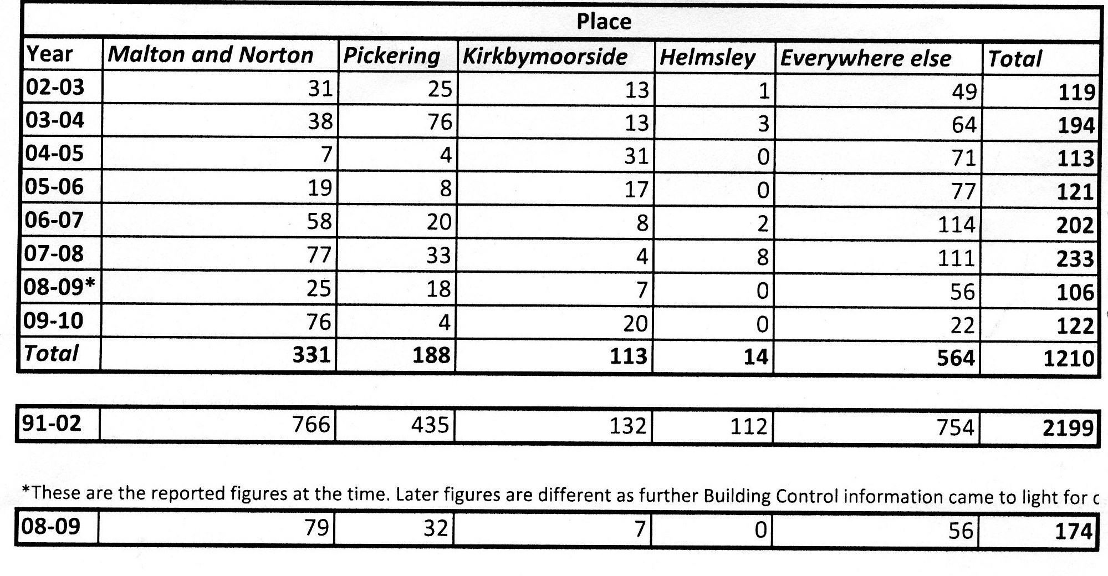
Source: Ryedale District Council - March 2011

NB As regards the figures for housing completions between 1991 and 1996in the above table, the size of Ryedale District was reduced on 31st March 1996, following the reorganisation of that date, so that Ryedale lost heavily populated parishes which include Clifton, New Earswick, Earswick, Haxby, Huntington and Strensall and which now form part of the suburbs of the City of York Council. It is not clear if the above figures include this area which was lost to York.

NB2. Although the parishes which were lost to Ryedale in 1996 occupy a small geographical area, they nevertheless represented a substantial concentration of population: the current population of Ryedale is 51,000, whereas before 1st April 1996, Ryedale had a population of about 90,000.

NB3. It will be seen that the for the years 1991 – 2002, there is a growth of 2,199 new houses. I understand that the Council’s records do not provide a breakdown of these figures(see figure2), and therefore it has been assumed that before 2002 there was an annual growth rate of 200 houses per annum, and this may have been the basis of the RSS housing requirement for Ryedale. If so, it should be treated with caution, as the growth rate may reflect new housing which was delivered outside the current boundaries of Ryedale District.

The housing policy in the current draft Ryedale Plan is a draconian mechanism designed to concentrate all new housing devlopment on Malton/Norton (50%), whilst treating the other towns as though they are more part of the countryside than Malton/Norton.

Malton & Norton have been classified as the ‘Capital’ or “Principle Town” of Ryedale and thus designated as the destination for most of the new dwellings. At the same time, the stimulus for the building of market housing in the villages (apart from 10 service villages) has been removed. This has been done in two ways. Firstly, by maintaining current development limits (without revision). Secondly, by requiring all new houses built within development limits to be subject to a ‘local occupancy’ condition, a requirement which will effectively reduce their sale value by at least 10%.

The Town Councils do not accept RDC’s housing strategies because:

- They artificially distort demand;

- Ryedale has an area of over 550 sq. miles; the district is sparsely populated, and there is plenty of space for building new houses in villages without risk of spoiling them or of overwhelming them with newcomers.

However, the town councils accept that Ryedale’s policies do accord with former regional policy of locating most housing development within towns. If these policies had been retained, it would be necessary to demonstrate that there are circumstances of local significance which would suggest that:

- There should be a smaller proportion of new houses in Malton/Norton;
- Other market towns and the villages should take their fair share of new housing development.
As regards (ii), Malton and Norton are only two of five market towns within the district. Pickering is larger than Norton, and the combined size of Pickering, Helmsley and Kirby Moorside is greater than Malton/Norton. In these circumstances, consideration should be given to requiring these three towns to take a greater share of new development than that required by the draft Ryedale Plan.
However, the draft National Planning Policy Framework published in July 2011 makes controversial suggestions about building houses in the country. It is understood that what is intended (however the document is worded) is not to prejudice or compromise the preservation of National Parks, Areas of Outstanding Natural Beauty, Green Belts, Conservation Areas, SSI’s etc., but is intended to make more land available for development in the open country.
In my view this is an entirely appropriate policy for Ryedale. Ryedale is a sparsely populated district with a population of about 51,000 inhabiting an area of 550 square miles – not all of it areas of Outstanding Natural Beauty, Green Belt, or National Park. Ryedale’s villages will stagnate without some new blood. Yet NIMBYism reigns supreme, and in order to preserve their own amenities, the country members of Ryedale District Council have done their utmost to dump most new development on Malton and Norton.
Malton and Norton have not adopted a NIMBYist approach. The town councils have said they would be prepared to accept 1,000 new houses (for the 15 years commencing January 2009 – the date when consulted). Unfortunately, this gesture has not been reciprocated by the rest of Ryedale – particularly the country areas.
At the meeting of 14th December 2011 at which the draft Ryedale Plan was approved, I proposed that the number of new houses for Malton and Norton should be limited to 1,000, and that the balance of 500 should be distributed evenly amongst the 100 or so rural villages. This was not accepted. It was said that this would destroy the whole basis of the housing policy set out in the plan.
It is not understood how this amendment would have fundamentally undermined the Council’s policy. A few new houses in the rural villages would not have altered the Council’s policy of concentrating development in the market towns and service villages.
However, it is suggested that this policy is itself in contravention of the government’s general policy of allowing more development in the open countryside.

Housing in relation to Employment

One of the reasons for the former government policy of concentrating most new housing development into the towns is the perception that employment is also concentrated in the towns.

The suggestion is that new houses need to be built near where people work, and therefore because there are many employment opportunities in Malton & Norton, it is there that most houses should be built.
This view does not take into account the way the countryside in Ryedale works. In cities, residential areas tend to be rigidly separated from industrial and commercial areas, and different classes of residence are found in different parts of a city.

Rural areas like Ryedale are different. The whole countryside is a working area – where food is grown and produced. In villages, people from all social backgrounds live side by side, tend to know each other and communicate. In the same way that people in a rural area are widely dispersed, so are many of the employment opportunities.
In this context it is not correct to regard the towns as the natural place for employment and the villages as a kind of expensive suburb. The countryside, country market towns and country living are completely different from the way of life in cities.

For example, in the area around Swinton, Amotherby and Kirby Misperton (about 3 to 6 miles west of Malton), the following employment opportunities and facilities exist or existed:

- Numerous farms (employing labourers and engaging contractors, farriers, vets etc.)

- Easterby’s racing stables, which employs about 50. The gallops go around the back of a village, and one block of stables is half a mile down the road. Easterby’s own houses within this village, which they let to their employees. Racing stables not only employ their own staff, but engage horse transport, vets, farriers and other contractors.

- Bulmer’s haulage – situated opposite the Easterby stables, this is a business which has grown out of farm diversification and was believed to employ more than 30, although it does not now operate from these premises;

- Flamingoland Zoo and Leisure Theme park, a national theme park and major local employer. This enterprise employs a large workforce, which comes from all the surrounding areas, including Malton. It not only employs its own staff, but engages transport, vets and other contractors.
- Eden Camp – a well known museum about the life and times of the Second World War with a national reputation – employs about 50 staff .

- BATA in Amotherby, a large business supporting farming.

- Westler’s foods, one of the district’s largest employers,

- A butcher’s shop, also selling general groceries;

- Several village post offices;

- Several churches;
- Two garages

- The Queen’s Head, a popular Chinese restaurant;

- The Grapes, Great Habton, a cordon bleu restaurant and pub;

- Other pubs, also serving food, in Great Barugh and Kirby Misperton;

- Several village halls (including a large one with excellent facilities at Kirby Misperton), a sports centre at Swinton, several village cricket grounds etc.

- A primary school in Amotherby

Working people are as likely to travel from Malton & Norton to these places of employment or recreation as they would do from the villages to workplaces or leisure opportunities in Malton & Norton.
It is therefore a flawed argument to say that people must live in Malton & Norton because that is where they will find work.

Further, this does not take into account the host of people who work from home, including commercial travellers, farriers, horse and farm animal vets, people who work on clearing land drains, stone blasters, garden designers, general workmen, IT technicians, and other self-employed work people.

In addition, evidence from the 2001 Census and RDC records confirms that the residents of Malton & Norton do not necessarily work in the towns.

Malton & Norton currently have a population of 12,370 of whom 9,736 are registered voters (Source RDC January 2011).

The 2001 Census provides the following employment figures:

Town | Full Time | Part Time | Self-employed
Malton | 1,459 | 500 | 385
Norton | 2,188 | 836 | 419
Totals | 3,647 | 1,336 | 804

This gives a total of 4,452 full-time jobs and 1,336 part-time jobs, making a total of 5,788 jobs. Although these figures are from 2001, it is unlikely that there will have been very much change since then, except perhaps downwards as a result of economies forced by technological change and the recession.

Another way of looking t this is to refer to Figure 1, from which it would appear that a population of 11,858 people will produce 6,854 working age population, of whom 5,586will be economically active.

Superficially this might suggest that the number of jobs is roughly equivalent to the number of economically active residents of Malton and Norton.

However:

- Account has to be taken of the number of jobs which are part-time;

- Account has also to be taken of the fact that Ryedale is an area of low unemployment, perhaps resulting in a higher proportion of economically active residents than the national average.

- The assumption that all the jobs available in Malton & Norton are taken up by Malton & Norton residents is inaccurate, as many people from elsewhere come into Malton & Norton to work, especially a large proportion of the workforce at the Bacon Factory, which is one of the district’s biggest employers.

So it is not unlikely that a net figure of between 1,000 and 3,000 of Malton & Norton’s working age population residents already work away from the two towns – either within the district or outside the district entirely.

Figure 4 below is a reproduction of Table 3 from the Ryedale Employment Land Review Report of October 2005, carried out by Knight Frank, showing ‘existing sites and premises to be released but protected’.

This document is reproduced in order to show the number and size of existing formal employment sites. Even without the inclusion of retail premises, restaurants, pubs, leisure facilities, schools, public sector, farms, racing stables etc., it will be seen that the total area of the ‘existing sites and premises’ listed within Malton & Norton is considerably less than one third of the total, and the proposed strategy of building over 50% of new housing in Malton & Norton for the purpose of enabling people to live close to their workplace is not based on the facts.

Figure 4

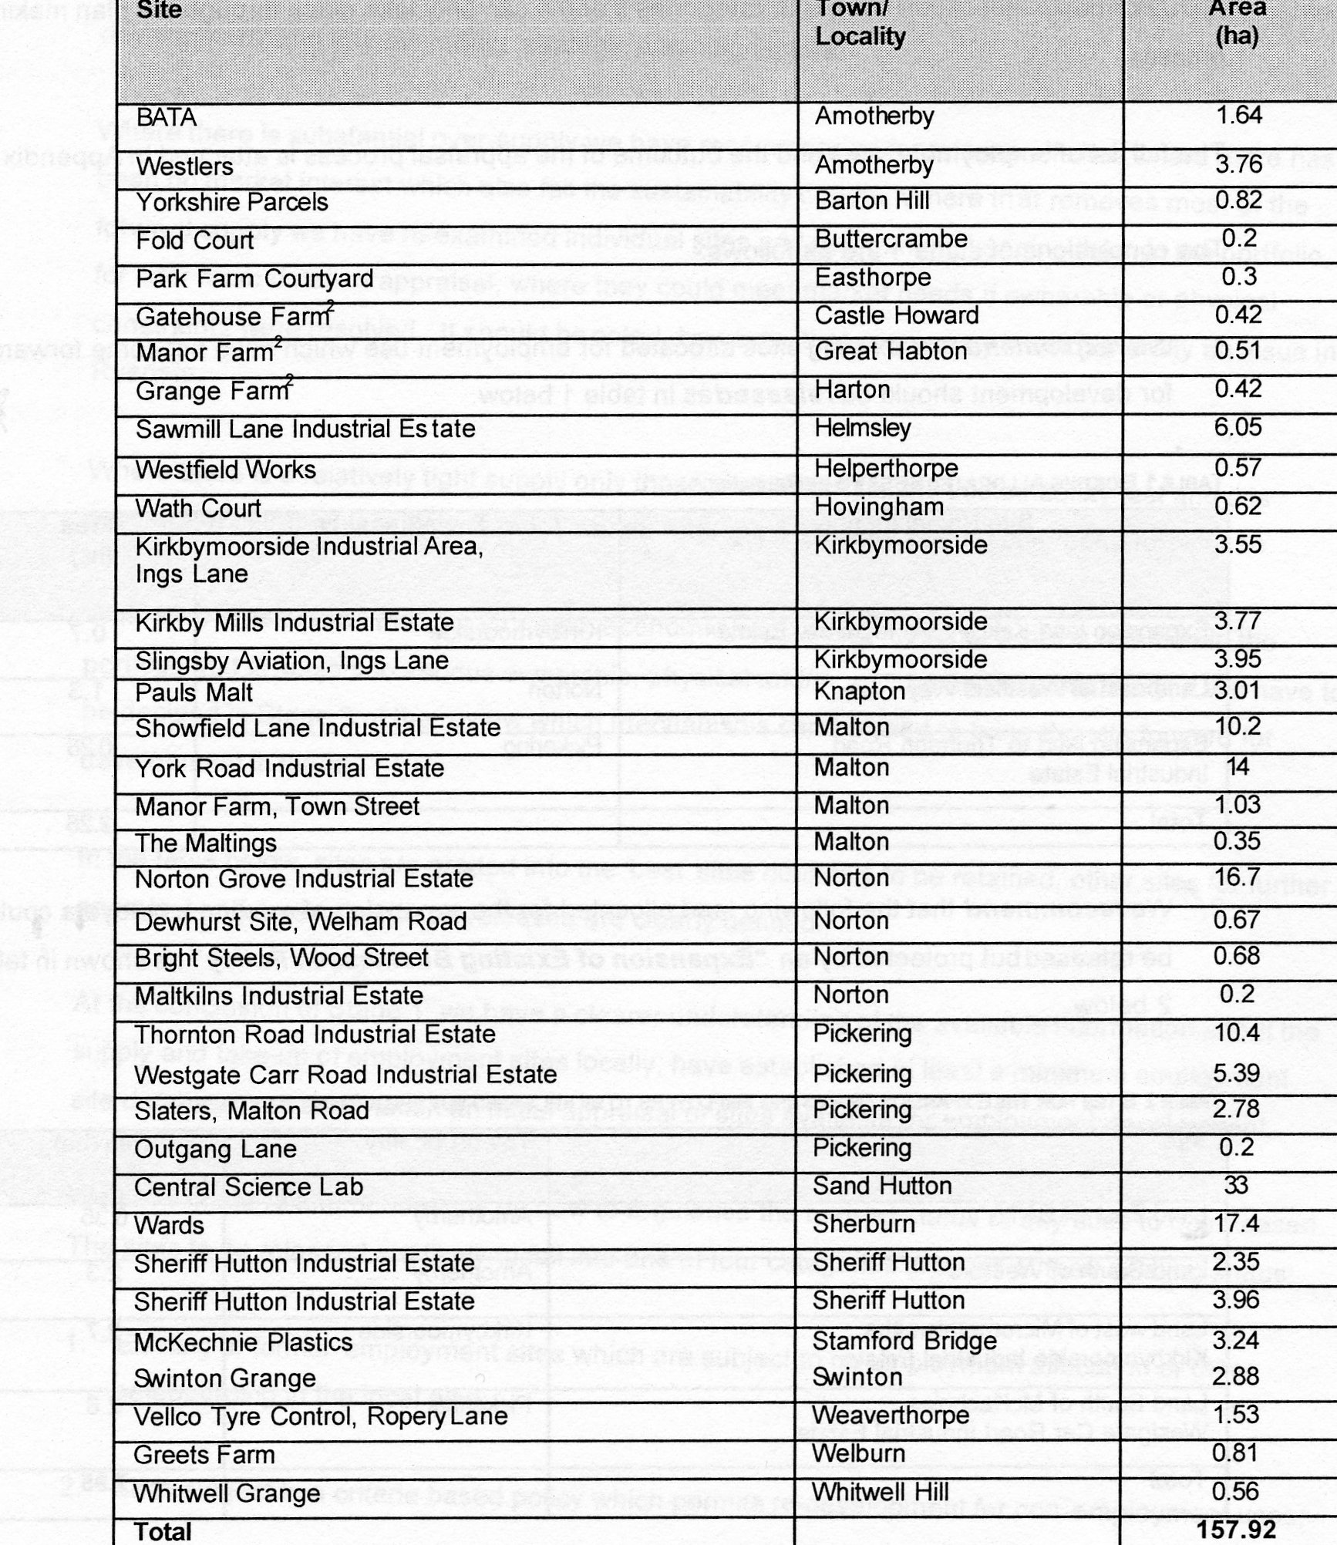

Housing and Retail

One of the strongest arguments in favour of concentrating housing in Malton and Norton is the view that the more houses in the town, the more the footfall for the shops. This is particularly pertinent in a recession, where shops everywhere are in difficulty.

RDC’s consultants, RTP, reported, in September 2008,:

‘Overall we consider Malton to be a healthy town centre, with no acute indicators of decline. Notwithstanding the issue of traffic congestion described above, Malton is a generally attractive and busy market town, which benefits from a varied convenience and comparison sector, good representation from financial service providers, a cinema, regular markets, a falling vacancy rate, low (good) yields and reasonable demand/interest from retail and service operators. Certainly we do not consider the vitality and viability of Malton has diminished since our previous health check of the town centre, undertaken in 2006.’

Since 2008, the recession has hit Malton & Norton hard and there are a large number of empty shops in the town centres.

We have to consider what has happened to footfall.

In a survey carried out for the year 2009, it appeared that nationally 12,000 independent shops closed in that year, but that the four big supermarket chains gained an increase in trade.

This corresponds with anecdotal evidence from Malton. We hear of people who live in the two towns who use the supermarkets but not the town centre shops. The supermarket car parks are always full, and Morrisons store is always crowded. Malton’s Morrisons store is now one of the biggest in the North East, drawing people from some distance, but there is little spin-off benefit for town centre shops. Morrisons are confident enough of their position to have built an extension in 2010.
Footfall is not a problem for them.

In other words, there is no shortage of footfall in Malton – the problem is that the footfall is mainly in the wrong place because Morrisons diverts customers away from the town centre.

In addition, many Malton and Norton people shop in York or Scarborough. The A64 is accessible from the towns and York is not far. Some consider it easier to get to York than into Malton itself, thanks to the congested junctions within Malton & Norton.

Given these facts, it would seem reasonable to agree with the findings of RTP in their 2006 and 2008 reports that the key to the prosperity of Malton town centre is the redevelopment of the Cattle Market. On this basis, the argument that more houses will produce more footfall for the town centre shops is not made out.

The Interim Malton and Norton Neighbourhood Plan

A consultation was conducted under the direction of a planning consultant engaged by the Town Councils who was instructed to carry out a strictly fair consultation which included the District Council’s preferred options as well as those of the Neighbourhood Plan. To date there has been no challenge to the fairness of the consultation.

The outcome of the consultation was as follows:

“ In total 420 people responded to the to the question of how many houses would be built over the next 15 years. The majority of respondents (152 people or 35%) agreed with the historic build rate of 915 houses over the next 15 years. This was followed by 28% suggesting 1,000 houses might be built. Only 18% suggested 1,500 houses.”(Page 5 Malton Town Council and Norton Town Council Neighbourhood Plan Community Consultation Summary of Responses – Appendix 6)

I put myself up for re-election in May 2011. I campaigned as an Independent on two main issues – no supermarket at Wentworth Street Car Park and no more than 1,000 new houses in Malton and Norton over the 15 year period commencing in January 2009. My assessment of popular opinion in the ward was that my campaign roughly confirms the proportions of popular opinion revealed in the Neighbourhood Plan Consultation.

The Neighbourhood Plan, approved as an interim plan by both Malton and Norton Town Councils in November 2011 contains the following policies:

1.To achieve a balance between retaining the distinctive nature of Malton and Norton and to stimulate the local economy;

2. To consider the scale and rate of growth of Malton and Norton using yardsticks of encouraging prosperity whilst retaining the amenities of a district centre;

3.New housing approvals for Malton and Norton should not exceed 1,000 over the period of the Plan;

4. Subject to (c) above, recommendations are made in regard to the sites which should be developed.

It will be seen that there is a difference between the outcome of the consultation and policy 3 above. Consultees were not asked how many new approvals should be granted: they were asked how many new houses they wanted to see built. There are already 470 approvals for unbuilt houses, and it will be seen that if these are added to the 1,000 new approvals, the District Council’s target of 1500 will be met.

Whether or not this discrepancy matters depends of course on when the 15 year period of the plan starts. If it starts at the date the District Council carried out their consultation (2009), any discrepancy between numbers of houses to be built and approvals to be issued will be insignificant.

Conclusion

I would accordingly ask the inspector to remit the draft Ryedale Plan and to invite Ryedale District Council to amend it so as to limit the number of new houses to be built in Malton and Norton in the plan period to 1,000, and to revise the plan, either by using the annual build rate as a guide, or by allocating 500 houses to other locations.

PAUL ANDREWS February 2012

