Ryedale District Council

2012
The draft Ryedale Plan
Pre-hearing representations
Paul Andrews, Malton Ward.

PRE-HEARING REPRESENTATIONS ON THE DRAFT RYEDALE PLAN

Of Councillor Paul Andrews

General

The inspector has before him two files with my representations labelled “Folder 1” (FI) “Folder 2” (FII), and a letter dated 5th May 2012 with my views on the implications of the new NPPF on the draft Ryedale Plan. This has attached to it a copy of a report by myself and a local surveyor, Paul Beanland. These notes are intended to bring my previous representations up to date. The letters FI and FII will refer respectively to the two folders.

Status of the Malton and Norton Interim Neighbourhood Plan (FIIAPP6).

Ryedale have taken the view that the Malton and Norton Interim Neighbourhood Plan should be given little weight. This is surprising, bearing in mind that Ryedale has applied to and obtained from the Department of Communities a grant of £20,000 for further work on the plan. Ryedale cannot have their cake and eat it. They cannot say that a document which is worth spending £20,000 on developing should be ignored and given little wieight.

In any case, Ryedale’s officers have no authority to argue that the neighbourhood Plan should be given little weight. The plan and the consultant’s report on the consultation were presented to Ryedale’s officers shortly after the Consultant’s report was issued. In spite of this, the officers have never presented either the plan or the report to a meeting of the Council or any of its committees. As council members have not been invited to consider the plan, the officers have no authority to recommend that it should be given little weight or ignored.

At the inspector’s pre-meeting it was stated that it was the draft Ryedale Plan which is under examination and not the Neighbourhood Plan. However it was accepted that the Neighbourhood Plan would be a material planning consideration, and that its policies should be given some weight. The question is: how much weight? My submission is that the weight which should be given to the policies set out in the “Interim Neighbourhood Plan” should depend on two factors:

- The reliability of the public consultation carried out as part of the Neighbourhood Plan process;
- The degree of sustainability of the Neighbourhood Plans policies in relation to their impact on the community socially, and also in terms of infrastructure, highways safety and management etc.

In terms of (a), unlike Ryedale’s consultation, a number of options was presented to the public, including the district council’s proposals and there has never been any suggestion that the consultation was unfair or conducted in an improper way.

As regards sustainability etc., if it is found that a policy in the Neighbourhood Plan is more sustainable than an opposing policy in the draft Ryedale Plan, then the policy in the Neighbourhood Plan should be given greater weight.

Allegations of inappropriate behaviour made against Ryedale

These are relevant to this examination in the following three respects:

- Firstly to determine whether the Council’s representatives have the necessary authority from elected members on relevant matters, and where such authority was obtained, whether or not Councillors were misled.

- Secondly, to assist in determining the weight which should attach to Council documents. In other words if a document is produced which has not been consulted upon or properly consulted upon, or properly submitted to the Council for debate, or where debate has been restricted or suppressed or members intimidated, the weight to be attached to that document should be downgraded. An example of this is the Strategic Transport Assessment of Jacobs which had been submitted to the Council offices in draft some considerable time before the meeting at which its subject matter was to be discussed; which was not available at that meeting; which was subsequently put out to public consultation – a consultation which was never completed and never reported to the Council; and which in an amended form was then placed upon the Council’s website and used as a working document even though it has never been formally approved by the Council (See FI Highways pp2-7 and FII pp 32 – 36 ex 17, 19 &20).

- Thirdly, normally at a public enquiry the local authority and its officers are considered to be the impartial guardians of the public interest, and this can give added weight to their evidence. However, the evidence of inappropriate behaviour demonstrated in my evidence should suggest that the Council and its officers are far too heavily influenced by the Council’s vested financial interests in regard to housing and retail. There is a possibility that Ryedale’s team ethic may have over-ridden the professional integrity of individual officers. Ryedale has therefore lost the right to be considered impartial or unbiased, and the weight which would normally attach to the evidence of the Council and its officers should be downgraded accordingly.

Context Vision and Objectives

I have already stated in my letter of 5th May 2012 why I consider the plan to be unsound in th4e context of the National Planning Policy Framework. Folders 1 and 2 cover the same ground in greater detail, although at the time the NPPF was not in force.
My main concern is that the plan does not achieve a fair balance between town and country. There is a clear intention to make Malton/Norton into a “New Settlement”, by forcing the towns to accept most new development, including substantially more than half the housing requirement, a brand new industrial estate where residents least want one, and a huge new superstore regardless of its likely impact on the vitality and viability of existing town centres in Ryedale.
There is an impatience for grandiose schemes involving high technology, instead of giving priority to building on the strengths of existing businesses in a district which has one of the highest employment rates and one of the lowest crime rates in the country. There is an emphasis on projects which can be financed from substantial developer contributions which only big business can provide, whilst small builders are left with only a few crumbs.
Ryedale is a sparcely populated district with just over 50,000 people living within a district with a total land area of about 550 square miles. Much of this includes the National Park, AOB’s, and other land with high amenity designations. However, the Council now wants to designate the entire area outside of the towns the Howardian Hills AOB and the National Park as “landscape of local value and areas of high landscape value” clearly with the intention of excluding further development from this and from most of the villages within it.
A substantial number of members of the ruling political group which comprises two thirds of Council members represent these areas, and the draft plan could best be described as a NIMBY charter which sterilises all areas outside the towns and concentrates most new development on Malton and Norton against the clear wishes of residents which have been evidenced at elections, in petitions and in a full and impartial, local public consultation.

Highways
This is a key infrastructure issue which should be addressed in determining the sustainability of the plan. As mentioned above, the plan as drawn is designed to make a “new settlement” out of Malton/Norton, and to this end most new development has been concentrated on these towns. One issue is whether or not the proposed new development is sustainable in terms of highways safety and junction capacity. If it turns out that the proposals are not sustainable in this respect, the plan will be unsound. It is therefore important that there should be a separate, detailed and thorough debate on the highways issue before any debate on housing, employment or retail matters.

Housing

I repeat my views previously expressed.

These views support the following changes to Policy SP2 and SP 5:

- Reduction of the annual building rate to 150 houses annually;
- Add to SP5:
- The delivery of new homes will be accomplished by revising and updating existing town and village development limits, so as to accommodate new dwellings without any local needs restriction. Houses built outside the revised development limits should be restricted to “exception sites” or to dwellings subject to local needs occupancy conditions.
- The distribution of new homes should be related to the ratios of existing houses in existing settlements, so as to ensure a fair balance between town and country, save that Malton and Norton will accept the building of no more than 1,000 new houses over the plan period.
- The policies in the Malton and Norton Interim Neighbourhood Plan in relation to housing distribution should be approved in principle.
- In allocating new sites, account should be taken of the policies of the Malton and Norton Interim Neighbourhood Plan and priority should be given to brown-land sites.
- The Sections on “other villages” and distribution should be amended accordingly to reflect the above bulleted points.
- Policy SP5 should be amended so as to delete the need to identify new traveller sites. Any new traveller requirements should be accommodated by the extension of the existing “Tara Park” site.

It should be noted that the Neighbourhood Plan Consultation makes it clear that residents would accept 1,000 new houses during the plan period. It should be noted that this includes houses which have permission, but which have not yet been built. The 1,000 figure in the Neighbourhood Plan therefore includes 450 unbuilt but permitted houses in Malton and Norton.

Incidentally it should be made clear in the plan as well as at the enquiry the date when the 15 year plan period is set to commence.

Economy – Employment land

I repeat my views previously expressed. These would support the following changes:

- Delete the first two bulleted points of policy SP6 and substitute: “27 ha will be allocated for additional employment land, subject to revision on each of the five yearly reviews of the Ryedale Plan; of this, 17.5 ha shall be allocated in Malton and Norton”
- Delete the reference to the provision of a new Science and Technology Business Park at Malton/Norton – provision for development of this kind should be made by extending existing business parks.
- The policies set out in the Malton and Norton Interim Neighbourhood Plan be approved in principle, and should be taken into account when preparing the Sites document;
- Such supplementary policies as may be appropriate to support these requirements.

Retail

I repeat my previous representations. Much has happened since these were submitted. This includes the grant of planning permission for a new superstore at Wentworth Street Car Park, the reference of that application to the Secretary of State and the subsequent application for judicial review against his failure to call the application in. At the time of writing the outcome of this is not known and this issue is therefore still live.

My previous representations included a copy of my representations against that planning application (FII). However, in order to bring these up to date, it would be necessary to attach a copy of the submissions I made to the Secretary of State requesting call-in. I fear that if these are not brought to the Inspector’s attention, the Council will simply say that all the relevant issues were examined by a supposedly impartial neighbouring authority, and should not be debated at this hearing. However, as the Committee Report on the Wentworth Street Site is likely to be relevant to the “Northern Arc” and the retail issue generally, I am attaching a copy of the text (without exhibits) of the submission which I made to the Secretary of State on this matter. I would ask the inspector to admit this document, as it relates to a committee report which was issued after the deadline for the submission of representations on the draft plan.

The Council have tried to exclude the supermarket issue from this hearing. This was achieved by ruling out of order the following motion proposed by Councillor Edward Legard at a Council meeting on 12th January 2012:

“The Council invites the Secretary of State to call in the competing Malton supermarket applications in order for their respective merits to be considered by way of public enquiry under the auspices of an independent planning inspector.”

The ideal venue for such an enquiry would, in my view, have been this hearing, as all the associated infrastructure, highways, Cattle Market Relocation issues could have been considered at the same time.

However, the Council were not allowed to debate this motion on the basis of a Counsel’s advice. Copies of the relevant correspondence are attached to FI as Annex 6. As noted in FI, I do not agree with the advice given by the barrister, particularly as she seems to have misunderstood the position of the Local Government Ombudsman on planning matters. Further, it is usual for Council solicitors when seeking legal advice to approach an organisation such as the LGA for help in selecting a barrister. I asked the LGA if they knew of Nathalie Lieven QC and I was told they did not. In the circumstances, I would invite the inspector to check M/s Lieven’s advice with the inspectorate’s own lawyers before the hearing.

As the Council were not allowed to debate this motion, and as elected members have never been asked to give a view on whether the retail issue should be referred to this hearing, I would suggest that the officers have no authority from elected members to exclude consideration of any aspect of the retail issues from this hearing.

It should be emphasised that there is nothing in the draft plan which would exclude consideration of the siting of new supermarkets within Malton and Norton. Indeed the reference to a defined “Northern Arc” in para 5.25 of the plan invites comment and debate on the size of this, its boundaries and whether it should be excluded in whole or in part.

Another reason for considering this matter now is that this is the only stage where it will be possible to deal with the issue of the relocation of the Cattle Market. It is common ground that the Cattle market needs to move and that it cannot stay where it is if either Wentworth Street Car Park or the existing Cattle Market is redeveloped. However, funds are required to achieve the relocation. One way of doing this would be for the redevelopment of the Cattle Market to be subject to the payment of a sum for relocation under a Section 106 agreement. This could be achieved if the developer was to be released from any obligation to pay other section 106 monies to the Council for highways or other infrastructure. The only opportunity to consider this issue will be at this hearing, as this is the hearing which will deal with issues relating to community gain (See FI paras. 5.1 – 5.15 and 27.11 – 27.15).

Quantitative need update.

The following table is an extract from the July 2011 Ryedale Retail Capacity and Impact Assessment Update of RTP.
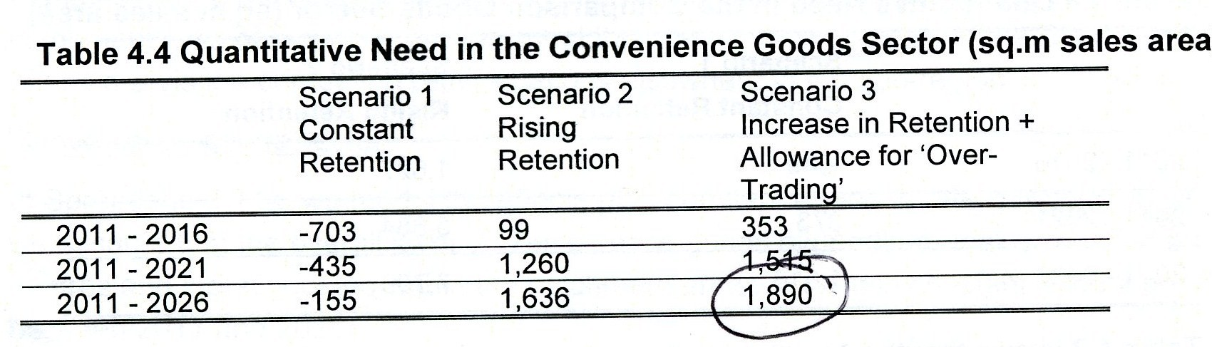
Scenarios 2 and 3 assume that 85% of the residents of the areas shown edged blue in Plan 1 below will shop at Malton if a new supermarket is built.

A local surveyor has drawn Plan2. He thinks Malton’s catchment area is largely defined by the red line on this plan, and that from this watershed shoppers will go to the easiest and most convenient retail outlets – particularly the sub-regional centres in Scarborough and York, and other district centres such as Thirsk, Easingwold , Beverley, Filey, Driffield and Pocklington. Scenarios 2 and 3 are therefore not realistic and cannot be supported.

The report by myself and Paul Beanland (attached to the enclosed report on the Impact of the Monks Cross Development – but also previously supplied as an attachment to my letter of 5th May 2012) sets out the argument in relation to Quantitative Need in a way which is perhaps more concise than in earlier submissions.

Plan 1

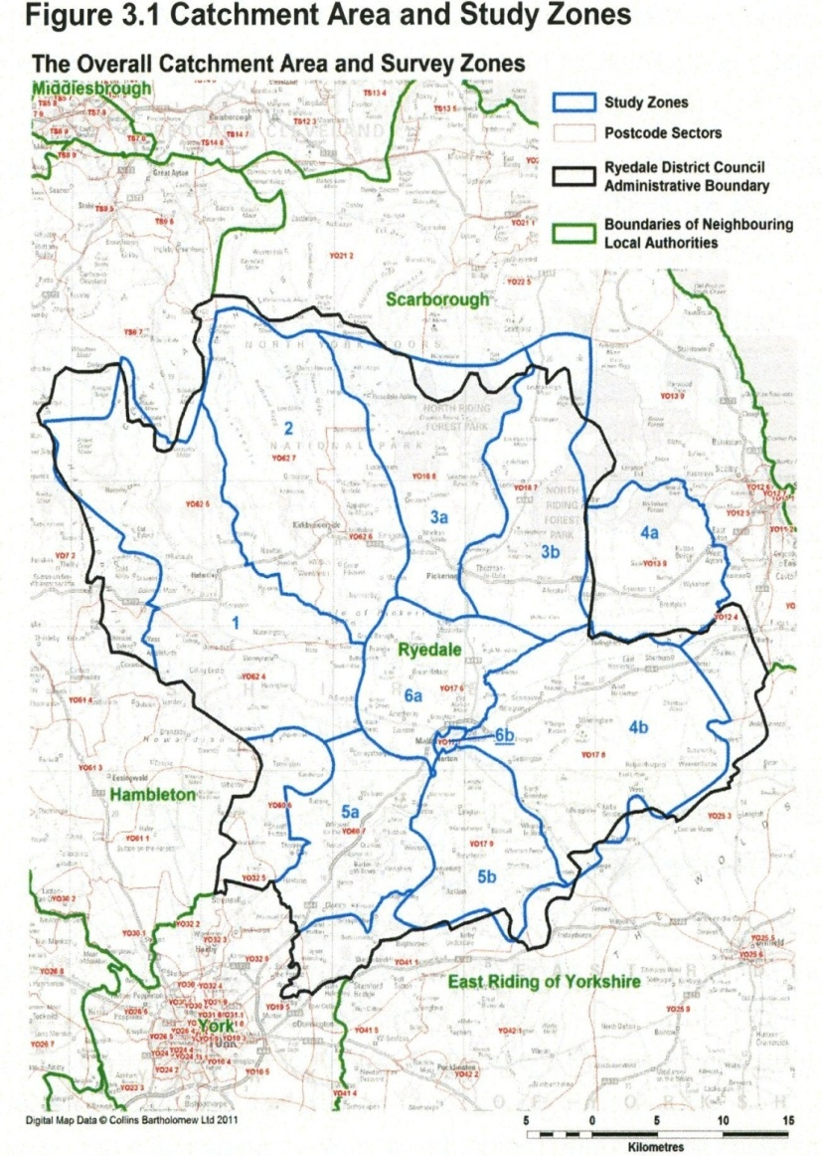
Plan 2

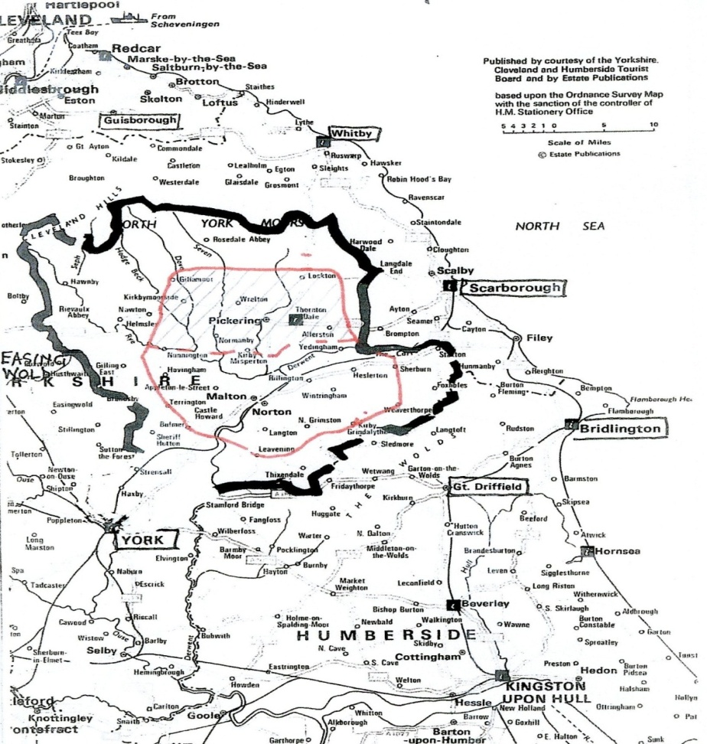

The July 2011 RTP Report, based as it is on flawed assumptions in regard to catchment and other matters, recommends a quantitative need of 1,890 sqm net convenience sales area – not just for Malton, but for the entire district.

It should be noted that:

- This report does not take into account the impact of the upgrading of the Netto store at Malton station from a deep discount store to a full ASDA supermarket (FI Retail pp10 &11 and Annex 5).

- The report antedates the permission given for Wentworth Street Car Park – which includes over 2,000 sq.m new net convenience sales area.

- Notwishstanding that the Wentworth Street Car Park consent takes up more than the 1,890 sq.m net sales area recommended by RTP for the whole of Ryedale, the Council granted planning permission on June 26th 2012 for a new TESCO supermarket at Kirby Moorside with a net sales area of 921sq.m. (812 sq.m. convenience and 109 sq.m. comparison)

- The Council’s argument has always been that a large new food supermarket would attract customers to Malton to buy more comparison goods and this would improve the Malton’s comparison offer, and it should be noted that about half of Ryedale’s “leaked” comparison shopping goes to York. However, all hope of this trade being recaptured in this way has been dashed by the grant of planning permission for a huge multi-million pound commercial development at Monks Cross York. An account of this and of its likely impact on Ryedale in general and Malton in particular is given in the attached Report on the Impact of these developments.

For all the above reasons, I conclude that there is no justification in terms of quantitative need for a new superstore in Malton or anywhere else in Ryedale. Further, as will be seen from my comments on the Committee Report referred to above, RTP accepted this in reports which were submitted to Ryedale in connection with the Wentworth Street Car Park application. However, they then proceeded to recommend the grant of permission on qualitative grounds, and a report of Arup was submitted, which they seem to have accepted at its face value without any detailed analysis. This was a highly generalised report which was weak on specifics. It relies on general statements such as the benefits of competition and the new employment the store might bring. Documentary evidence can be provided if required.

In doing so, they said nothing about jobs which might be lost from existing businesses.

There is, for example, a report by the National Retail Planning Forum – financed by Sainsbury’s, Tesco, Marks and Spencer, Boots and John Lewis –on superstore impact on employment. This found:
- Strong evidence that new out-of-centre superstores have a negative net impact on retail employment up to 15 km away;
- The 93 stores the forum studied were responsible for the net loss of 25,685 employees;
- Every time a new supermarket opened, 276 people lost their job;
- The New Economic Foundation has calculated that every £50,000 spent in small local shops creates one job, but you need to spend £250,000 in superstores for the same result.

I will endeavour to obtain a copy of this before the hearing.

However, the fact remains that Malton Town Centre does require an anchor to improve its range and diversity, and in this respect I would say I am not against supermarkets in principle. I believe that a supermarket which has the right size, location and character can improve a town, whilst a supermarket which is too big and built in the wrong place can destroy a town. So I would accept that there is a qualitative argument for a new supermarket in Malton. The question is: where, what size and what type?

The draft Ryedale Plan identifies an area called Malton’s “Northern Arc”. As this area has been identified, its precise boundaries have to be a subject for debate. Although one may not consider existing planning applications at this hearing, current proposals are likely to give an idea of how the sites might be developed.

On this basis it would appear that because of the geographical gradient of the land, the most likely form of superstore development on Wentworth Street Car Park is a building which has its main entrance facing away from the town centre and onto the car park, with the access to the car park at Pasture Lane. However many pedestrian connections there may be to the town centre, this is unlikely to encourage shoppers to visit the town centre, if they can get everything they need in the superstore.

On the other hand a much smaller top-of the-range food supermarket in the Cattle Market Area, with a main entrance which faces the Shambles is likely to encourage top-range shoppers who don’t normally shop in Malton to use the store and do other shopping in the town centre. This will encourage new shops with a greater range and diversity. This is not just my opinion or the opinion of the land owners, it was also the opinion of Ryedale District Council and of RTP in documents published by both of them between 2006 and September 2008 – before the Council started thinking about the money they could make by selling to a superstore (See FI Retail Annexes 2 and 3).

Added to this, there is the evidence of Sainsbury (FII24.2) and Simons( FIIAPP1) that Wentworth Street car park is not a suitable site for a superstore; rumours that TESCO have said they are not interested because as the site is within a residential area, they would have difficulty with over-night deliveries, and the fact that the site has been advertised on the WEB since October 2008 and so far none of the superstore chains has pursued an interest in the site to final acceptance (FI Retail development Brief dated 1st October 2008 referred to in and annexed to Annexx2).

The Council resolved to grant planning permission for Wentworth Street Car Park in April. The matter was then referred to the Secretary of state, and he declined to intervene in a letter dated 12th June 2012. I attach a copy of correspondence which followed this. However, it is understood that the Secretary of State’s Decision is now subject to challenge by judicial review. There is therefore no final decision and it is suggested that either consideration of the retail issues should be deferred unti l after the final decision on the application or alternatively, all relevant retail issues should be debated now subject to the inspector withholding his decision letter until he knows the outcome of the application for judicial review.

From the point of view of district councillor, the town needs a rapid resolution of this issue. It could all have been resolved after 2006, if the Council had not decided to let their own vested financial interest in the car park over-ride the public interest. It is not fair on Malton or its businesses for a decision to be deferred to another protracted planning exercise.

The Council included the “Northern Arc” in the plan. So the Northern Arc should be examined. There is nothing in the document which precludes such an examination, and, as mentioned above, the officers have no authority from elected members to argue against debating this.

My proposed amendment to the draft plan is as follows:

- The “Northern Arc” and all references to it should be amended to exclude the area Northeast of Wheelgate/Newbiggin.

- That policy SP 7 Food (Convenience) Retail be amended by:

  - Deleting “1,890 meters of food retailing (convenience) space will be directed to Malton” and substituting: “Provision shall be made for the redevelopment of a suitable site in the remaining part of the “Northern Arc” to include a top-range food store with a net sales area of not more than 1,700 sq.m, to be designed so as to encourage an improvement in th4e range and diversity of town centre shops”

  - That the threshold for convenience only schemes be set at 250 sq.m net sales area and the threshold for combined schemes be set at 500 sq.m net sales area

- That with special reference to Malton, the retail policies in the Malton and Norton Interim Neighbourhood Plan be approved in principle.

- That the redevelopment of the Cattle Market should be subject to the payment by the developers or land owners of a reasonable but substantial sum to assist with the relocation of Malton’s Livestock Market. This should be in lieu of any payments which might otherwise have to be made under policies relating to Section 106 agreements or community benefit, and should not exceed the amount which would have been payable under such policies.

Other issues
I reaffirm all comments previously made, and confirm my view that the plan is unsound. I feel that the inclusion of the amendments suggested above would go some way to making the plan sound.

Councillor Paul Andrews 17th August 2012

